Remotely Control Pi using Xbox 360
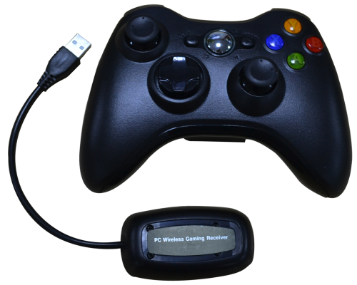

1. Remotely Connect with Raspberry pi

2. Connect the reciever of X Box 360 to the USB port of pi.
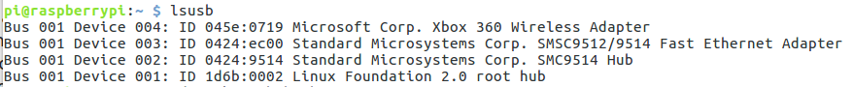
3. Install RetroArch(RetroPie Script) on Raspberry pi
Download:
sudo apt-get update
sudo apt-get install -y git
cd
git clone git://github.com/petrockblog/RetroPie-Setup.git
Installation:
cd RetroPie-Setup
chmod +x retropie_setup.sh
sudo ./retropie_setup.sh

